**GROUP PROJECT, GROUP 3**

**DATE: 20 October 2018**

**TIME: 15:30PM – 18:00PM**

**ATTENDEES** Tom Gibbs, Henry Crofts

**LOCATION:** , Atrium Building

**Minute Taker: Henry Crofts**

**Overall aims of the current sprint *(Detailed tasks, user stories and time allocations are tracked on JIRA)***

* To apply design theory principles to the Management Game.
* Spend time in labs together to improve team efficiency.
* Book meetings with Rob Kurta, Dave Pimm, and Chris Janes.

**Meeting:**

All team present.

The team met up to start discussing the design of the game working on a whiteboard to discuss the theory. As we were writing things out on the board we started to understand what the other member was trying to explain as there were parts of the game where Tom misunderstood Henry and Henry misunderstood Tom, this really helped the team realign the direction of the game and has greatly reduced the risk of either member producing incorrect / unneeded code once the team moved more into the development stage.

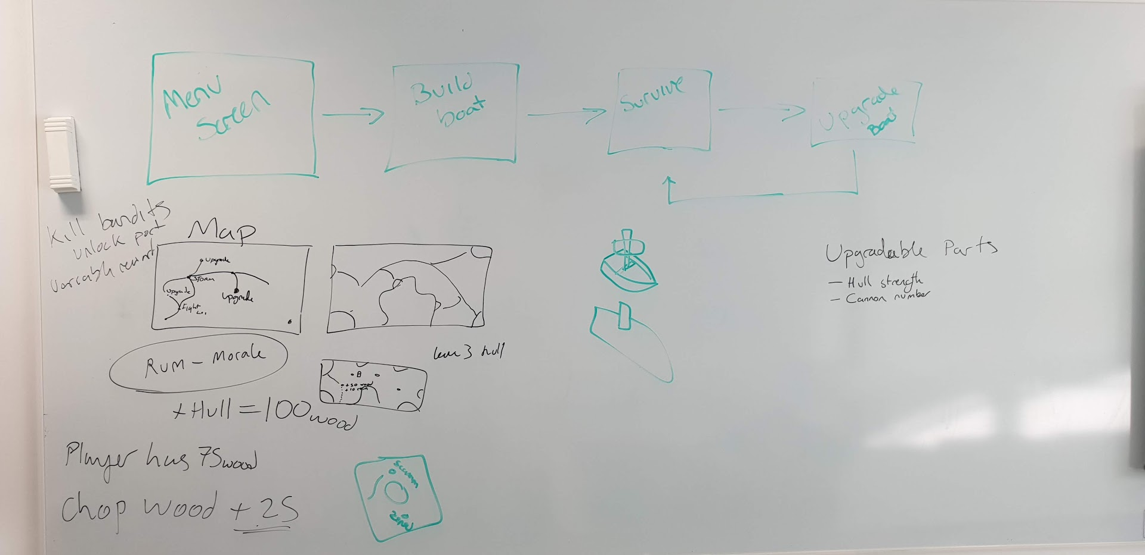

The team started off by explaining how the outline of the game would play with players being greeted with the menu screen, once they select *“PLAY”* they will then begin the game by building their boat, once the boat is build and the player is happy with it they will then move on to play the levels and *“SURVIVE”* by completing the level, once the level is completed the player will be able to *“UPGRADE”* their boat to become stronger and invested in the game, they will then be in the loop of *“SURVIVE”* and *“UPGRADE”*. We spoke about adding in a map feature between levels giving the player a visual representation of where they are, with the idea of building each level as a world and players completing mini levels within that world in the form of Level 1-1 -> level 1-2 -> level 1-3 etcetera similar to the old Super Mario levels.

We then went on to talk about how the level would look upon the boat;

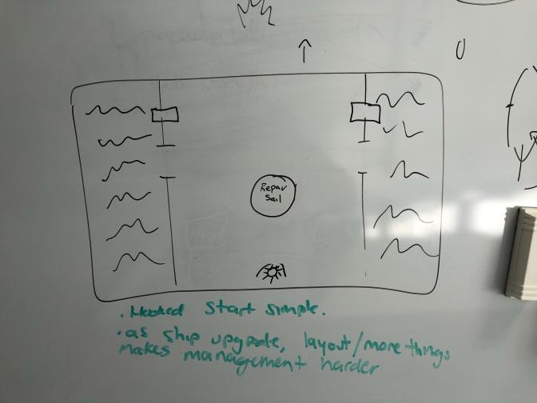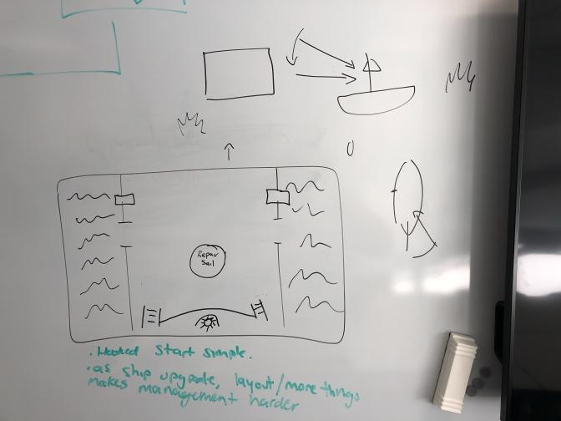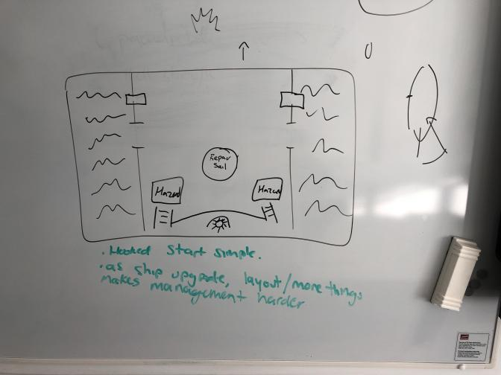

We played with the idea of the *“STEERING WHEEL”* object being stored up some stairs that only has two access points to increase the difficulty, this is something we are still trying to figure out and will have to perform some playtesting to find out how well players will be able to cope with only two access points, especially if two hazards appear at either entrance, this might make the game too hard but might also cause the panic we are aiming for.

We also spoke about the *“ENEMY SHIP”* appearing to the side of the players ship and how the *“ENEMY SHIP”* will behave when it appears, for now we have both agreed that the game will warn the player that there is an *“ENEMY SHIP”* to the side of their ship by slightly panning the camera in the direction of said hazard (unsure if the enemy will have a model or if they will be just off screen). The player will then have X amount of time to fire the cannon to damage the enemy and make them “*CIRCLE AROUND”* for another pass, if the player is unable to fire at the enemy ship in time the enemy will fire a cannon at the player ship damaging the *“HULL HEALTH”* and causing a *“HAZARD”* in the form of a hole in the ship, the player will then need to fix this hole, another design problem we have come across here is does the player fully repair the hole in the ship or do they just place a *“PLANK OF WOOD”* down so they are able to still walk over that hazard but some water may wash the plank away exposing the hazard again, another feature we have been discussing is persistent damage over levels where after levels instead of *“UPGRADING”* the ship the players can choose to *“REPAIR ALL”* and use their resources to repair all persistent damage for the next level.

The team there started to discuss some of the *“ACTIONS”* and *“HAZRDS”* that will be present in the game, for the actions we spoke about the cannons, this could include *“RELOADING”*, *“AIMING”* and *“FIRING”* with the players having to use different actions for each interaction, when loading the cannon the player will need to get a cannon ball from the *“CARGO HOLD”* and carry it over to the cannon, however this will slow the player down by X amount until they are able to drop the cannon ball or load it into the cannon.

To repair the mast, we are still unsure on how this could be done correctly, as to whether this will be a repair the sail, strengthen the mast with more wood or repair the rigging.

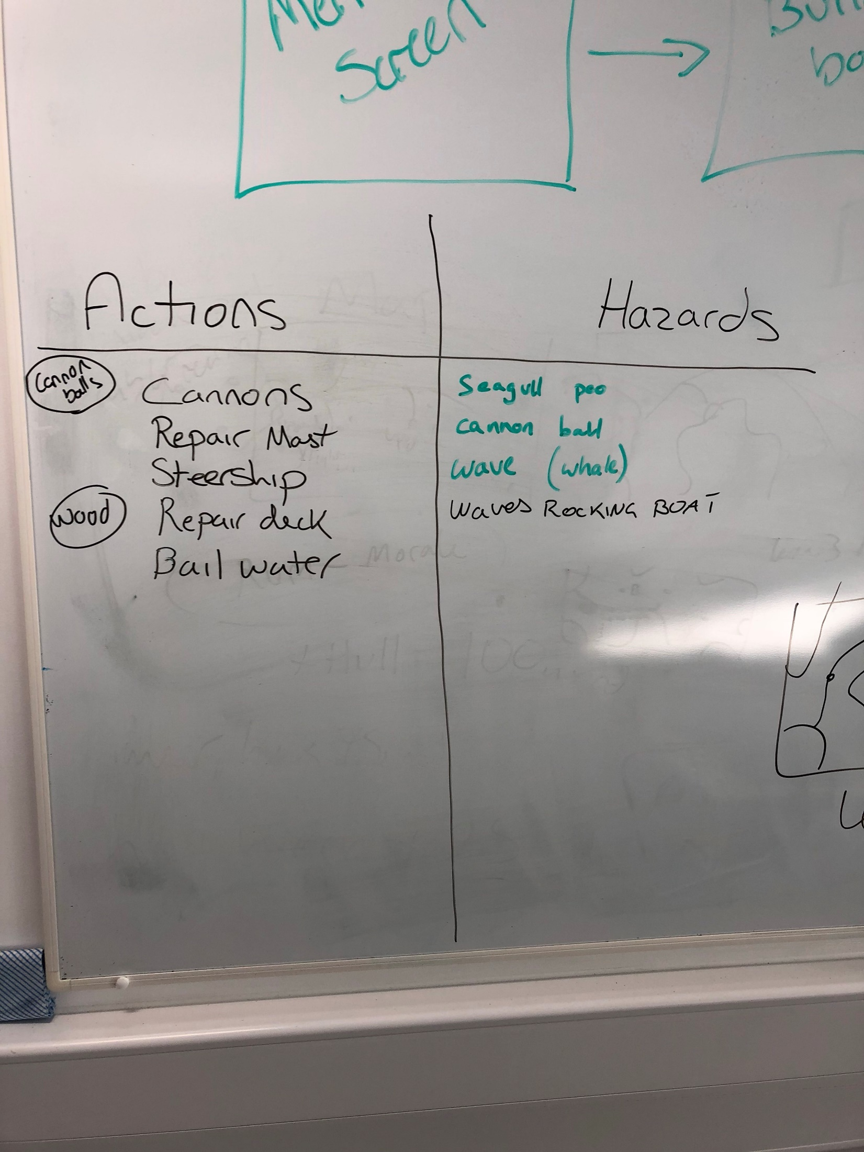

As with the *“ENEMY SHIP”* and the camera panning slightly in the direction the hazard will be, we have also been designing the idea that a hazard will appear in front of the player’s ship that will need to be avoided, this will be shown by the camera slightly panning downwards instructing the player to make their way to the *“STEERING WHEEL”* and interact with it, the ship will then adjust its course itself leaving the player to rush off and deal with another hazard. I spoke about the repairing of the deck earlier in the minutes. Bailing water out is something the team is working towards having a diegetic timer / health for the level and the players will be able to bail out the water to give themselves more time while also having to deal with other hazards.

The hazards we have been discussing as *“SEAGULL POO”* that the player might slip on and send them across the ship, this hazard was to add a slight comedic value to the game, the *“CANNON BALL”* as explained earlier will slow the player down as they are carrying it. The *“WAVE (WHALE)”* is a mechanic we thought about putting into the game where a whale will appear somewhere in the level to indicate that a big wave is coming, if they players don’t notice the whale appear and are standing in the open parts of the ship they will be knocked off into the water (we are still deciding if the player will respawn after X amount of time or if they would have to sit the rest of the level out). *“WAVES ROCKING THE BOAT”* was as idea where the boat would rock at times making it harder for the player to move around the boat and maybe move some of the lose items around the ship.

The team then spoke about other ways that we might be able to show the timer and health of the ship at the same time, with the time always dropping down to 0 and the health bar would be constantly going up and down depending on what the player is doing and what hazards are currently active.

As a team we have agreed to meet again to have a game jam style meeting in the labs where the team will work on designing more of the game and making sure that all members of the team fully understand all aspects of the game.

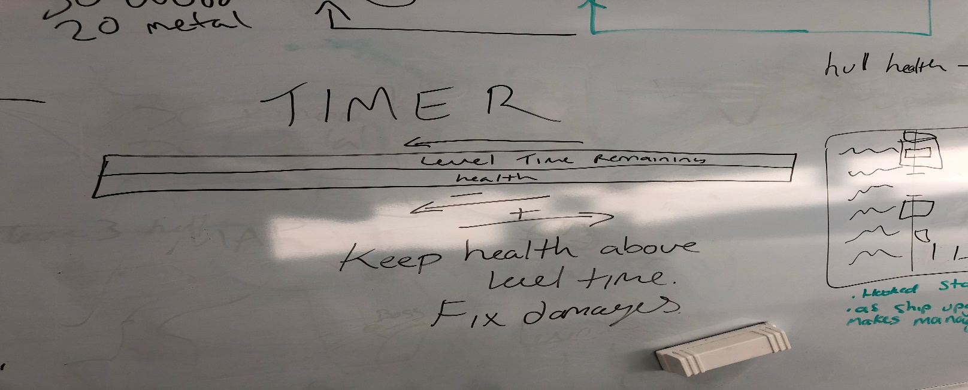

Next team meeting scheduled for Tuesday 23rd October

**Tasks for the current week:**

**Tom (12 Hours):**

* **As suggested by Dan spend time in the labs as a team in a game jam setting to increase team efficiency (8h)**

Dan Mayers agreed that we would benefit from spending time together in the labs to work together in a game jam / studio environment especially during the design phase.

* **Look into *“Guns of Icarus”* and see if there is any design choices that could be helpful to our game (45m)**

Extract design choices from a game called *“Guns of Icarus”* and pull out any design choices and balancing they do that could help with the progress of our game.

* **Meet with Rob Kurta (45m)**

Meet with Rob to discuss some of the design choices we have made in the game from the theory we have researched.

* **Meet with Dave Pimm (1h)**

Meet with Dave to discuss some of the design choices we have made in the game from the theory we have researched.

* **Meet with Chris Janes (30m)**

Detail types of immersion. Find examples of each, corresponding skills tested. Why they are effective.

* **Write a Design Document (1h)**

Write a brief design document outlining the direction the project will take to send to Dan Mayers

**Henry (12 Hours):**

* **As suggested by Dan spend time in the labs as a team in a game jam setting to increase team efficiency (8h)**

Dan Mayers agreed that we would benefit from spending time together in the labs to work together in a game jam / studio environment especially during the design phase.

* **Look into *“Pixel Piracy”* and see if there is any design choices that could be helpful to our game (45m)**

Extract design choices from a game called *“Pixel Piracy”* and pull out any design choices and balancing they do that could help with the progress of our game.

* **Meet with Rob Kurta (45m)**

Meet with Rob to discuss some of the design choices we have made in the game from the theory we have researched.

* **Meet with Dave Pimm (1h)**

Meet with Dave to discuss some of the design choices we have made in the game from the theory we have researched.

* **Meet with Chris Janes (30m)**

Detail types of immersion. Find examples of each, corresponding skills tested. Why they are effective.

* **Write a Risk Assessment Document (1h)**

Write a risk assessment showing the risks involved with the project and how the team aims to mitigate them and send to Dan Mayers

***Detailed tasks, task descriptions, user stories and time allocations are tracked on JIRA.***